MPlayerGUI
User Guide

Disclaimer
This software is provided "as-is".
No warranty of any kind is expressed or implied.
The author will be liable for data loss, damages, loss of profits or any other kind of less while using or misusing this software.
Any suggestions, feedback and comments are welcome.

Homepage
E-Mail: jasonyang9@163.com
Web site: http://sourceforge.net/projects/mplayerguiwin
Blog: http://jasonyang9.blog.163.com

Supported Platforms
PC x86 Windows 95, 98, NT, Me, 2000 & XP

Introduction
MPlayerGUI is an Open Source GUI (Graphical User Interface) Front-End for MPlayer. It works under Microsoft Windows operating system. Since MPlayerGUI depends on MPlayer, you can treat MPlayer as the engine and MPlayerGUI as the shell. For information about MPlayer, check out the MPlayer's Homepage at

http://mplayerhq.hu/

Features
- A Media Player with Simple and Native User Interface
- Easy and Intuitive Design
- Plays most popular Video and Audio Formats, including MPEG, ASF/WMV, MOV,RM/RMVB, OGG/OGM, MP3, WMA, FLV, 3GP and more
- Small in size, less than 15 MB to download (Full Package), less than 1 MB to download (Lite Package)
- Very light CPU and RAM load
- Configuration saved in .INI file, portable
- No installation is required, unpack and run
Minimal System Requirements
- 100 MHz processor or equivalent
- 32 MB of RAM
- 20 MB available disk space
- VGA (640 x 480) or higher-resolution video adapter and monitor
- MS Windows 9x
- MS DirectX 7 (for MPlayer)

For Windows 9x users, please read “How to use MPlayerGUI under Windows 9x” in the FAQ section.

Recommended System Requirements
- 500 MHz processor or greater
- 256 MB or RAM
- 50 MB available disk space
- Super VGA (800 x 600, 65k color) or higher-resolution video adapter and monitor
- MS Windows 2000 or XP
- MS DirectX 9 (for MPlayer)

About releases compressed with 7z
To decompress .7z files, get 7-zip (An Open Source Project) from

http://www.7-zip.org/

Or upgrade to the latest WinRar.
User Interface

Progress Bar
This is the bar used to show the progress and navigate the film or audio file.

Toolbar Buttons
Toolbar Buttons are some most used functions (left to right):

- Play
- Pause
- Stop
- Previous
- Next
- Repeat
- Playlist
- Mute

Volume Slider
Volume Slider is used to set the volume.

Status Bar
Various useful information is shown on the status bar. It shows player's current status, played time and total time. Additional information like Album, Title, Artist, Genre of current playing file are shown on the status bar also.

Playlist
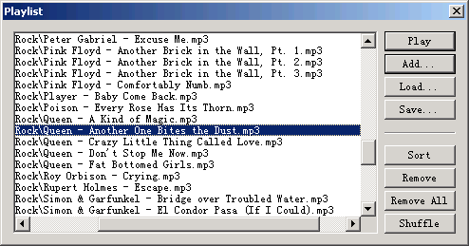
Playlist is a modaless dialog box, it contains a listbox and a few command buttons, you can add files to the listbox and manage them and play them one by one.

- To play a file and its subsequent, double click it;
- To add files, use the Add button or drag them from Explorer and drop to listbox;
- To save a playlist, use the Save button;
- To load a playlist, use the Load button;
- To sort the playlist in alphabetical order, use the Sort button;
- To remove a file, use the Remove button;
- To remove all files, use the Remove All button;
- To shuffle the playlist, use the Shuffle button.

Settings
The Preferences dialog has several pages, they are:

Engine
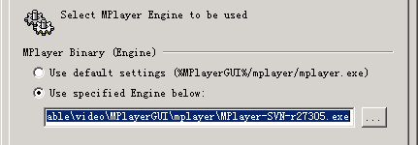
Since MPlayerGUI uses MPlayer as its engine, you have to tell MPlayerGUI where is the MPlayer binary file (ex: MPlayer.exe) located. Select "Use default settings" if you place MPlayer binary file in a directory structure like the following:
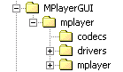
or select "Use specified Engine below:", fill the edit box with the pathname of the MPlayer binary file you perfer. You can also use the "Browse" button to locate it.

Output
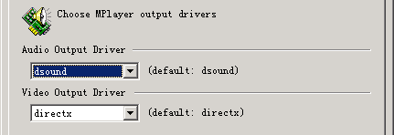
Audio Output Driver
Available Audio Output Driver:

- nosound (Do not decode and play sound)
- null (Decode but ouput no sound at all)
- dsound (use DirectX DirectSound audio output driver)
- win32 (use native Windows waveout audio output driver)

You should use dsound if it works well.
Video Output Driver
Available Video Output Driver:

- novideo (Do not decode and play video)
- null (Decode but output no video at all)
- directx (use Microsoft DirectX with acceleration)
- directx:noaccel (use Microsoft DirectX without acceleration)
- gl (use OpenGL)
- gl2 (use OpenGL v2)
- direct3d (use Microsoft Direct3D)

You should use directx or direct3d if it works well, otherwise try directx:noaccel.

Video
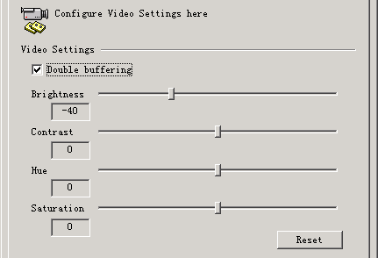
Double buffering (video)
Enable Video double buffering. (According to MPlayer's Manual) Double buffering fixes flicker by storing two frames in memory, and displaying one while decoding another. It can affect OSD negtively, but often removes OSD flickering. Enable double buffering if the Subtitle is on, otherwise you can disable it.

You can configure video Brightness, Contrast, Hue and Saturation in this page also. These settings will not take effect during a playback, a restart is needed.

Player
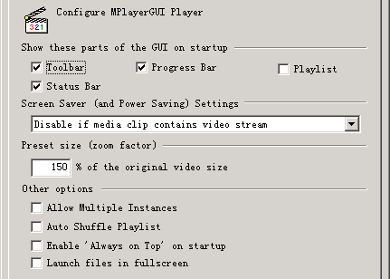
Show these part of the GUI on startup
Set to show or hide the following GUI elements on startup:

- Toolbar
- Status Bar
- Progress Bar
- Playlist

Screen Saver (Power Saving Settings)
When playing, you would like to disable Screen Saver, here are the options:

- Don't disable
- Disable when playing
- Disable if media clip contains video stream (recommended)

Preset size (zoom factor)
Set preset zoom factor.

Allow Multiple Instances
Enable or disable Multiple Instances of MPlayerGUI Application. In most cases, disable it.

Auto Shuffle Playlist
Enable this to auto shuffle playlist everytime the playlist rewinds itself.

Enable 'Always on Top' on startup
Enable this to let MPlayerGUI Always on Top on startup.

Launch files in fullscreen
Enable this to start playback in Fullscreen mode (video only).

Subtitles
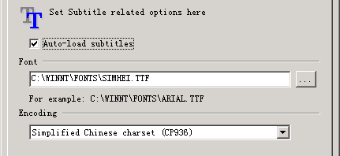
Auto-load subtitles
Enable or disable auto-load subtitles. To get it work, the movie file and the subtitle file must look like this:

some-movie.avi
some-movie.srt

Font
Enter the TrueType font's pathname for Subtitles. You can also use the '...' button to pick a system font. (experimental)

Encoding
Select desired Subtitle Charset Encoding.
For example: To display Chinese Subtitle, user have to:

Set Font as 'C:\WINNT\FONTS\SIMHEI.TTF' (宋黑)
Set Encoding as 'Simplified Chinese charset (CP936)'

For more information, please refer the MPlayer's Manual.
Association
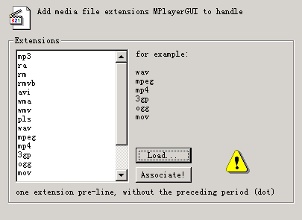
Assoicate media files to MPlayerGUI, then user can play a media file by double clicking it in file manager.

Type in the file extensions to the 'Extensions' box or use the 'Load...' button to load a pre-defined file. One sample pre-defined file: 'types.txt' is added to the release package. After filled the 'Extensions' box, press 'Associate!' button.

Commands

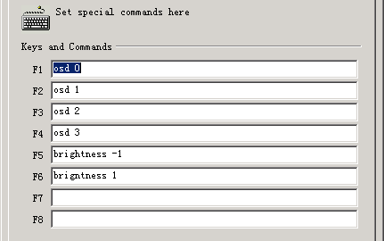

You can set some special commands (slave commands) here, press the corresponding keys to send them to MPlayer when playing. (for debugging purpose mostly)

Reference:

http://www.mplayerhq.hu/DOCS/tech/slave.txt

Advanced
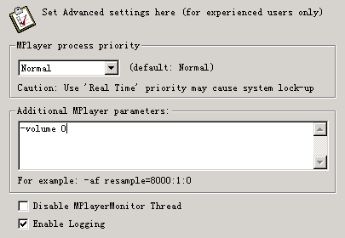
MPlayer process priority
- Idle (put MPlayer to the background, may cause interruption)
- Below Normal
- Normal (Recommended)
- Above Normal (Boost performance a little)
- High
- Real Time (May cause system lock-up!)

Additional MPlayer parameters
This is for experienced user only! Please refer to the MPlayer's Manual.

http://www.mplayerhq.hu/DOCS/HTML/en/index.html
http://www.mplayerhq.hu/DOCS/HTML-single/en/MPlayer.html

Disable MPlayerMonitor Thread
For debugging purposes only.

Enable Logging
For debugging purposes only.
First enable logging, then user can open MPlayer’s output log window by using menu item View -> Log to check MPlayer’s output.

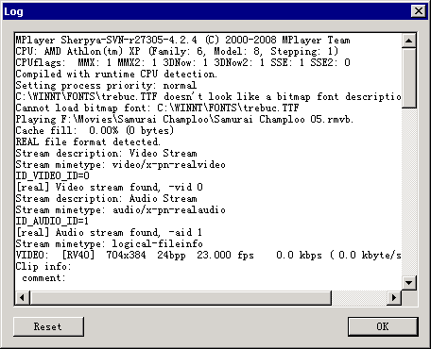
The log shows what is going on “under-the-hood”.
When there is something goes wrong with MPlayer, the log contains basic information about errors, you (Advanced Users) can use it to troubleshoot problems by yourself.

For example, when the parameters is wrong, MPlayer will refuse to play anything, the log should contains this error message, and it could give you a clue:

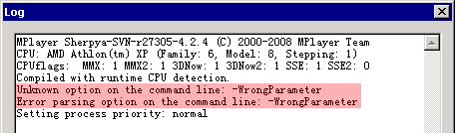

Miscellaneous

Accelerator
During the playback, you can use these accelerator keys:

- Ctrl + Right (fast forward 10 seconds)
- Ctrl + Left (fast rewind 10 seconds)
- Ctrl + Up (fast forward 1 minute)
- Ctrl + Down (fast rewind 1 minute)
- Ctrl + Page Up (fast forward 10 minutes)
- Ctrl + Page Down (fast rewind 10 minutes)
- Space (Pause/Resume)
- Period (Stop)
- Ctrl + M (Mute/UnMute)
- Ctrl + T (Toggle Always On Top)
- Alt + 1 (Zoom 50%)
- Alt + 2 (Zoom 100%)
- Alt + 3 (Zoom 200%)
- Alt + 4 (Preset Zoom Size)

Playlist Specification
A list of links to files makes a valid generic playlist. The entry can be relative (i.e. \files\song.mp3) or specific (i.e. c:\media\files\song.mp3).

Here is a sample generic playlist file:

Sample.txt (or Sample.pls)

Alternative\Band - Song.mp3
Classical\Other Band - New Song.mp3
crap.mp3
F:\more music\foo - bar.mp3

- Alternative and Classical are sub-directories of the directory that this playlist is stored in.
- "Band - Song.mp3" and "Other Band - New Song.mp3" are in sub-directories that this playlist is stored in.
- "crap.mp3" is in the same directory that the playlist is stored in.
- "foo - bar.mp3" is in the specified directory, which may or may not be the same directory the playlist is in.

More on Playlist
You can open a playlist file or drop in a playlist file, MPlayerGUI will load the playlist and play them one by one from the first entry in the list.

The playlist file has an extension of .txt or .pls

About Internet Stream (Net Radio) Playback Support
You can play Net Radio via the File | Open URL... command, paste the URL of Net Radio (for example: mms://160.79.128.12/smoothjazz_low) and click Open, MPlayer will connect to the server and start playback automatically.

MPlayer will cache data first, you can see the caching progress in status bar.

(Cache fill: xx.xx%)

If your Net Radio play is always buffering (and skipping), try to increase the buffer size of MPlayer by edit the config (MPlayer\mplayer\) file, for example:

cache=1024

which means the cache buffer is set to 1024 KB (1 MB), set it to a larger number to get smooth playback. Try 2048 or 4096 for example.

This leads to another issue, the initial buffering time will becomes very long, if you can't wait, use the following trick:

cache-min=10

this will tell MPlayer to start playback when the cache has been filled up to 10% of the total. Your playback starts pretty early, but still builds up a large buffer while playing, so that later download interruptions are not noticed.

See MPlayer's User Manual for details.

When playing Net Radio, the position bar is disabled, and the total playing time is always 00:00, this is normal.

Sometime the Net Radio server becomes very busy, MPlayer can't get new data from the server for a very long time, and it will stop. You can set MPlayer to retry automatically by enable the repeat mode.
Frequently Asked Questions (FAQ)

MPlayerGUI won't play anything, statusbar shows 'Engine not found!'
This means that MPlayerGUI can not find the Engine (MPlayer). If you are using the MPlayerGUI Full Package, select 'Use default settings' in 'Engine' property page. Otherwise, specify a valid Engine.

I can't do a lot of things with MPlayerGUI under a Windows 9x System?
Due to a bug in MPlayer (Bug No.320) you just can't right now! I'm sorry. I hope MPlayer Team can fix this bug soon.

http://bugzilla.mplayerhq.hu/show_bug.cgi?id=320

Or you can do this:

How to use MPlayerGUI under Windows 9x
Since there is a bug in MPlayer, when MPlayer works under Windows 9x it doesn't receive the slave commands that a front-end sends to it. It seems that all mingw builds have this problem. But the cygwin builds are not affected by this bug.

So in order to use MPlayerGUI under Windows 9x, you have to do the following steps:

- Download the MPlayerGUI Full Package if you don't have it yet.
- Download a MPlayer build with cygwin, from here. Unpack it to wherever you want.
- Edit "c:\autoexec.bat" and add this line to the end of file:

SET HOME=C:

- Reboot your Windows 9x box
- Copy your MPlayer configure to this file: "c:\.mplayer\config" (no extension)
- Edit MPlayerGUI.ini in your MPlayerGUI directory, add one line to the end of file:

bBypassWinVersionCheck=true

- Run MPlayerGUI and go to the preferences dialog, in the Engine page select "Use specified Engine below" and choose the MPlayer (build with cygwin) you downloaded. And don't forget to save the settings.
- Done.

Reference:

http://smplayer.sourceforge.net/forums/viewtopic.php?id=95

MPlayerGUI hangs up?
For some unknown reasons, MPlayer.exe stops reading the stdin sometime, after a while, the command pipe jammed. In this case, you can terminate the MPlayer.exe process in the Task Manager. Thus MPlayerGUI.exe will start to response again. Anyway, you should file a bug report to me via the Email when this happens.

I can't play [insert media format here] with MPlayerGUI?
Try to download more codecs from MPlayer web server:

http://www.mplayerhq.hu/MPlayer/releases/codecs/

place them in the codecs directory of MPlayer and try again.

